# Installation Steps

Download the Windows installer from the [Nodes.js® web site](http://nodejs.org/).

Run the installer (the .msi file you downloaded in the previous step.)

Follow the prompts in the installer (Accept the license agreement, click the NEXT button a bunch of times and accept the default installation settings).  
[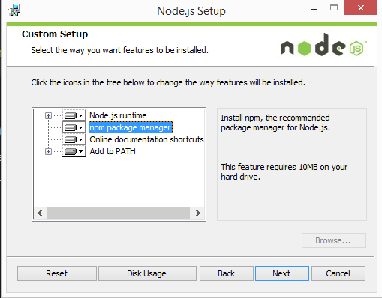](http://blog.teamtreehouse.com/wp-content/uploads/2015/01/installer.png)

Restart your computer. You won’t be able to run Node.js® until you restart your computer.

# Test it!

Make sure you have Node and NPM installed by running simple commands to see what version of each is installed and to run a simple test program:

Test Node. To see if Node is installed, open the Windows Command Prompt, Powershell or a similar command line tool, and type **node -v.** This should print a version number, so you’ll see something like this **v0.10.35.**

Test NPM. To see if NPM is installed, type **npm -v** in Terminal. This should print NPM’s version number so you’ll see something like this **1.4.28**

# The web framework

The first goal is to setup a simple HTML webpage that serves out a form and a list of messages. We’re going to use the Node.JS web framework express to this end. Make sure [Node.JS is installed](http://nodejs.org/).

First let’s create a package.json manifest file that describes our project. I recommend you place it in a dedicated empty directory (I’ll call mine chat-example).

{  
"name": "myapp",  
 "version": "0.0.1",  
 "description": "my first socket.io app",  
 "dependencies": {}  
}

Now, in order to easily populate the **dependencies** with the things we need, we’ll use **npm install --save**:

npm install --save express@4.10.2

# Integrating Socket.IO

During development, socket.io serves the client automatically for us, as we’ll see, so for now we only have to install one module:

npm install --save socket.io

# Steps to run the sample

1. Open the command promt.
2. Navigate you sample folder ../myapp.
3. Run the below command

Node index.js

1. Open your browser to <http://localhost:3000>
2. Click “**Export Svg on Server**” Button
3. Now go to the sample folder and check your diagram will be saved as sample.svg.